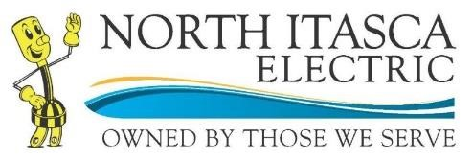

***Heat Pump Water Heater Rebate Form 2025***

301 Main Ave S ~ PO Box 227 ~ Bigfork, MN 56628-0227

Phone: 218-743-3131 Toll Free: 800-762-4048 Fax: 218-743-3644

support@nieci.com

[www.northitascaelectric.com](http://www.northitascaelectric.com/)



**Member Information:**

Name: ____________________________________________________________ Account #: _____________________

Mailing address: ______________________________________________City: _________________________________

State: _______________________ Zip ___________________________ Phone: _______________________________

Rebate Requirements:

Complete rebate form

Include a copy of your original sales receipt showing the item purchased.

Provide packaging showing the ENERGY STAR logo rated product purchased.

**By signing this application, I certify the appliances for which I am claiming a rebate are qualifying products and are installed at the address listed above which represents a valid cooperative account.**

Members Signature: ________________________________________________________ Date: _________________

**Heat Pump Water Heater**  $500.00 rebate

Manufacturer __________________________________

Model Number _________________________________

Reimbursement method: (Accounting code – 908.11)

|  |
| --- |
|  |

Please credit my account

|  |
| --- |
|  |

Please send me a check

Cooperative Rep: __________________________________________________________ Date: _________________

# N140.C 1.24