**Please call Roxanne to verify if it is still available- 218-743-3132**



**GTD38EASWWS Regular $569.56 SALE $512.60**

GE, white 7.2 c.f. electric dryer with up to 120’ venting, reversible door, moisture sensor.

**GTW385ASWWS Regular $ 572.16 Sale $514.94**

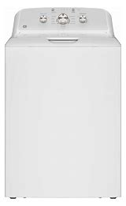GE, white 4.3 c.f. top load washer with dual action agitator and sanitize with Oxi, water level control, deep rinse, stainless drum, late lid lock safety, status notification lights.