LG appliances
WT6105CW- $567.23 SALE $510.55
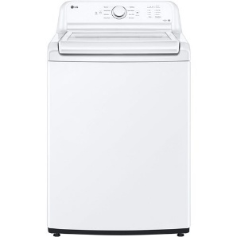
LG, white 4.1 c.f. ultra large capacity top load washer with 4-Way® Agitator. SlamProof glass lid, deep fill option, Intelligent electronic controls with dual LED display. Dial-a-cycle control knob, never rust stainless steel drum, true balance anti- vibration system, smart Diagnosis, direct drive motor with 10-year warranty. Eight wash programs: normal, heavy duty, deep wash, bedding /waterproof, delicates, speed wash, tub clean, spin only. Four wash options: extra rinse, control lock, deep fill, rinse+spin. 3 wash/rinse temperatures: hot, warm, cold. Water levels: load sensing.
WT7005CW- $849.33 Sale $764.40
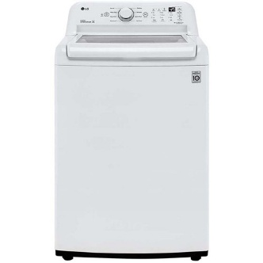
LG, white 4.3 c.f. ultra large capacity top load washer with 4-Way® Agitator. TurboDrum and 6Motion Technology, deep fill option, ColdWash Technology. Eight wash programs: normal, heavy duty, deep wash, waterproof, bedding, delicates, speed wash, tub clean. Nine wash options: ColdWash™, signal, delay wash, rinse+spin, deep fill, max, extra rinse, control lock, spin only. Three wash rinse temperatures: hot, warm and cold. Three spin speeds: high, medium and low. Load sensing water levels, 3 soil levels. Add garment indicator.
WT7000CW- $770.03 SALE $693.03
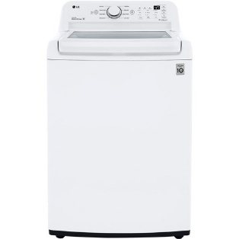
LG, white 4.5-Cu. Ft. ultra large capacity, TurboDrum technology creates a powerful water flow for an enhanced but gentler clean, SpeedWash cycle, 6Motion technology, SmartDiagnosis, or with a simple app on your smartphone, Water Plus option, ColdWash technology. nine wash options: ColdWash™, signal, delay wash, rinse+spin, water plus, soak, extra rinse, control lock, spin only. Three wash & rinse temperatures: hot, warm and cold. Three spin speeds: High, medium and low. Water level: load sensing.
WT7150CM-$ 872.70 SALE $785.43
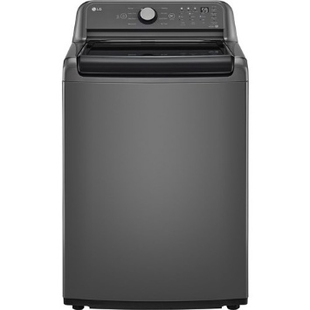
LG, middle black 5.0 c.f. ultra large capacity top load washer. SpeedWash cycle, slam proof glass lid, water plus & cold wash options, intelligent electronic controls with dual LED display, Dial-a-cycle control knob, NeverRust stainless steel drum, TrueBalance anti- vibration system, Energy Star certified, direct drive motor with limited 10-year warranty. Eight wash programs: normal, heavy duty, deep wash, waterproof, bedding, delicates, speed wash, tub clean. Nine wash options: soak, extra rinse,delay wash, control lock, water plus, cold wash, signal, rinse+spin, spin only. Three wash tempertures: hot warm and

DLE7150M- $852.93 SALE $767.64
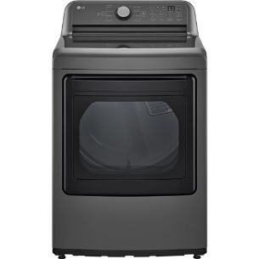
LG, middle black, 7.3 c.f. ultra large high efficiency electric dryer. Intelligent electronic controls with dual LED display, Dial-a-cycle control knob, reversible door, FlowSence duct clogging & clean filter indicators, wrinkle care option, low decibel quiet operation, smart diagnosis, Energy Star certified. Eight programs: normal, perm press, heavy duty, bulky/bedding, delicates, speed dry (manual dry), air dry (manual dry), freshen up (manual dry). Seven dryer options: wrinkle care, control lock, more time, less time, damp dry signal, energy saver, signal. Three temperature settings: High Medium, and low. Three drying levels: very dry, normal dry and damp dry. Manual dry times: 60.40,20 min, more-less.
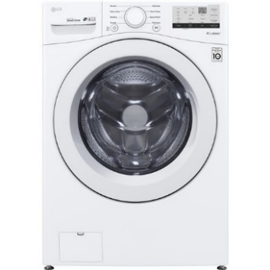
DLE3400CW- $871.43 SALE $784.29
LG 4.5 c.f. white front load washer, closet depth, Energy Star certified, Direct drive motor 10- year limited warranty, never rust stainless steel tub, LG SideKick compatible, ColdWash Technology, 6Motion Technology, 4 tray dispenser, Normal cycle, delicate cycle, towels cylcle, speed wash cycle, bedding cycle, tub clean cycle,prewash, rinse hold, pre-wsh dispenser, autoo load sensing, SenseClean system, TrueBalance, loDecible quiet operation, end of cycle signal, auto sud removal.

WM3400CW- $871.43 SALE $784.29
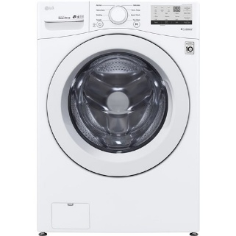
LG, white 4.5 c.f. front load washer. Closet depth, Energy Star certified, Direct drive motor with 10-year limited warranty. NeverRust stainless steel tub, ColdWash Technology, 6Motion Technology, 4 tray dispenser. 8 wash programs: normal, perm. press, heavy duty, delicates, towels, speed wash, bedding, tub clean. Eight Wash options: prewash, delay wash, cold wash, extra rinse, rinse+spin, child lock. Five wash rinse temperatures: hot, warm, semi warm, cold and tap cold. Three spin speeds: high, medium and low. Max RPM 1300, Water Levels: load sensing, adjusted by sensor except during speed wash.

DLE7400WE-$983.45 SALE $885.10
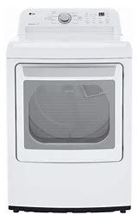
LG 7.3 c.f. EasyLoad dryer, eight cycles,five temperture selections, quick express cycle, reversible door, sensor dry cycle, timed dry cycle, Voice controlled, wrinkle free cycle, door opens sideways or pull down. Works with Android, iOS or Google Assistant.
Energy Star certified.

DLE36OOV- $1023.22 SALE $920.90
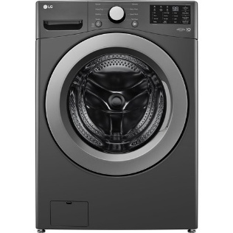
LG, middle black 7.4 c.f. vented stackable electric dryer with sensor dry technology. Dry cycles: air fluff, bedding, cotton, delicates, heavy duty, permanent press, quick dry, sensor dry, timed dry, towels and sheets, wrinkle free. Dryer features: adjustable legs, control lock, damp alert, door window, 4-way venting, front controls, lint filter, moisture sensor dry, timed dry. Aluminized steel drum.
WM3407OCM- $1079.00 SALE $971.10
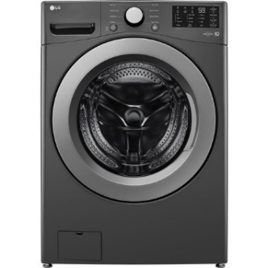
LG, middle black 5.0 c.f. capacity front load washer with ColdWash. capacity, 6Motion Technology, cold wash technology, direct drive motor 10-year limited warranty, Energy Star, closet depth, NeverRust Stainless Steel Tub, True Balance Anti-Vibration System & LoDecibel Quiet Operation, Tub Clean, System, Smart Diagnosis. Eight wash programs: normal, perm press, heavy duty, delicates, towels, speed wash, bedding, tub clean. Eight wash options: pre-wash, delay wash, cold wash, extra rinse, rinse + spin, control lock, spin only, signal. Five wash rinse temperatures: extra hot, hot, warm, cold, tap cold. 3 soil levels. Load sensing water levels. Five spin speeds: Extra high, high, medium, low, no spin, cold. Three spin speeds: high, medium, low. Water levels automatically adjust to the size of the load. Three soil levels.

WM6998HVA- $2174.17 SALE $1956.75
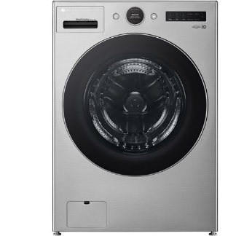
LG 5.0 c.f. silver mega capacity front load wahser/dryer combo Combination washer and dryer Wash and dry in as fast as 2 hours, Greatest energy savings up to 60% with Inverter HeatPump Technology, LCD digital dial control, ezLintFilter design, Go-anywhere sleek ventless design. 30 programs: wash+dry, AI wash+dry, normal, AI wash, bedding, delicates, towels, quick wash, heavy duty, allergiene, perm. press, dry only, delicate dry, perm. press dry, tub clean, bright whites, sanitary, rinse+spin, spin only, hand / wool, activewear, swimwear, kids wear, jeans, dresses, color care, sweat stains, small load, large load, xl load. 18 moptions: TurboWash®, Steam, Fresh Care, pre-wash, remote start, delay wash, wi-fi, add item, extra rinse, control lock, drum light, cold wash, detergent level, softener level, signal, cycle list edit, cycle optimization, softener tank. Five wash rinse temperatures, 5 spin speeds,

LDFN4542W- $649.35
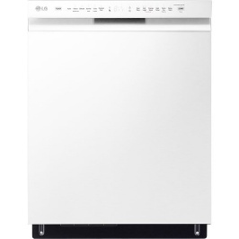
LG 24” white front-controlled dishwasher, 48 dBA, QuadWash, EasyRack Plus, 3rd rack, Dynamic Dry, never rust stainless steel tub. Nine programs: auto wash, heavy, delicate, normal, turbo, download cycle, machine care, rinse, express, SenseClean. Features: Water soil sensor, LoDecibel quiet operation, Vario wash, detergent dispenser, rinse aid dispenser, water heater, delay wash, QuadWash, safety float switch, BPA free, Anti-bacterial, 3-stage filtration system, adjustable racks
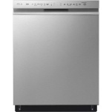
LDFN4542S $669.60
(Same as above but Stainless)

LRGL5823S-$1O56.17
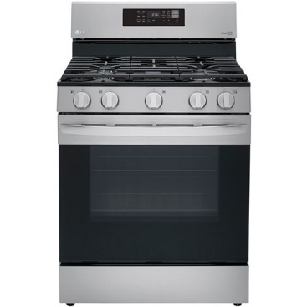
LG stainless/black 5.8 c.f. gas range with Convection, Air Fry, Convection roast, convection bake, and keep warm options. ThinQ and proactive customer care. Self clean and eeasy clean features. Premium wide grates with cast iron griddle. 7 oven rack positions. Compatable with Amazon, Alexa and Googe Assisant. Fan convection circulates air for faster, even cooking.

