SPEED QUEEN WASHERS
TR3003WN - $1036.26
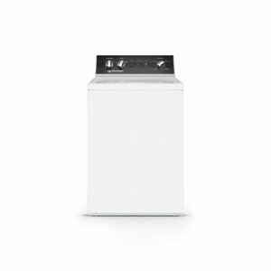
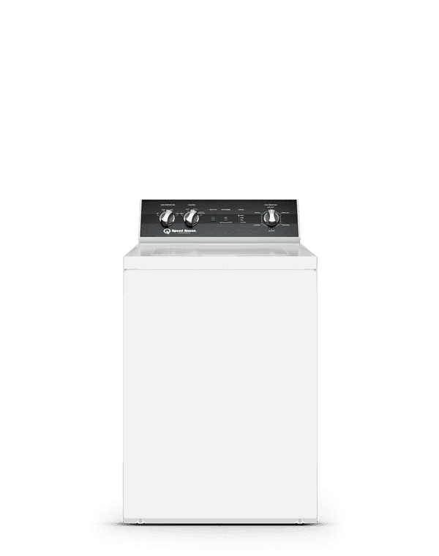
3.2 c.f. stainless wash tub, automatic balancing, agitator, Speed Queen Perfect Wash action, variable speed 1 HP motor. 4 preset cycles, 3 temperature selections, 3 load size selections, 2 soil level selections, quiet agitation (43dB), extra rinse, max spin speed 820 RPM.
3-year parts and labor warranty.

TR5003WN- $1125.96
3.2 c.f. stainless wash tub, automatic balancing, agitator, Speed Queen Perfect wash action, variable speed 1 HP motor. 6 preset cycles, 4- temperature selections, 3 load size selections, 2 soil level selections, quiet agitation (43dB), extra rinse, max spin speed 820 RPM. 5-year parts & labor warranty.
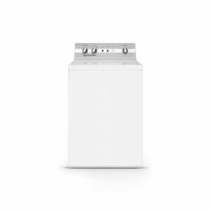
TC5003WN- $1214.36
3.2 c.f. stainless wash tub, automatic balancing, agitator, Speed Queen Classic Clean wash action, two-speed 1/2 HP motor. 6 preset cycles, 4 temperature selections, 2 load size selections, 2 soil level selections, soak cycle, quiet agitation (43dB), extra rinse, max spin speed 710 RPM. 5-year parts & labor warranty.

TR7003WN- $1305.38
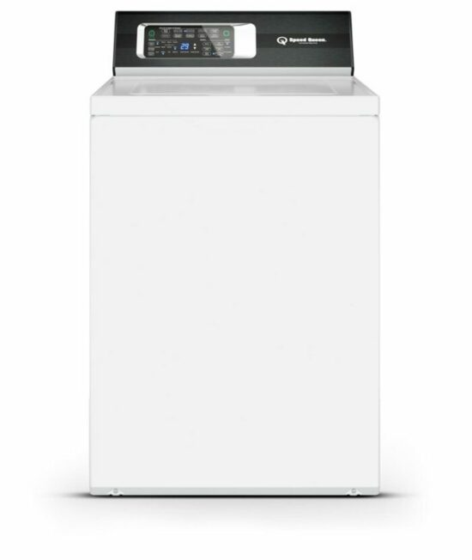
3.2 c.f. stainless wash tub, automatic balancing, agitator, Speed Queen Classic Clean wash action, variable speed, 1 HP motor. 16 preset cycles, 4 temperature selections, 4 load size selections, 4 soil level selections, soak cycle, prewash, quiet agitation (43dB), extra rinse, warm rinse, max spin speed 820 RPM. 7-year parts & labor warranty.

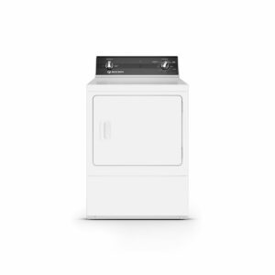
SPEED QUEEN DRYERS

DR3003WN- $1031.55
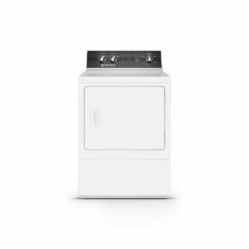
7 c.f., 1/3 HP motor, 3 preset cycles, 3 temperature selections, cylinder light, reversible door, upfront lint filter, over dry protection technology. Energy Star certified. Three-year parts and labor warranty.

DR5004WE- $1121.90
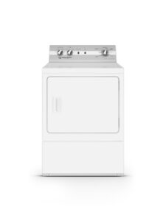
7 c.f. sanitizing electric dryer with steam, Over- Dry protection technology. 9 preset cycles, 5 temperature selections, steam refresh, steam boost, extended tumble, moisture senser, commercial cool down technology, Energy star certified, cylinder light, reversible door, up front lint filter. Five-year parts and labor warranty.

DC5003WE- $1213.55
7 c.f. sanitizing electric dryer with extended tumble. 1/3 HP motor, multiple vent options, 4 preset cycles, 4 temperature selections, Sanitize, cylinder light, reversible door, up front lint filter. Five-year parts and labor warranty.

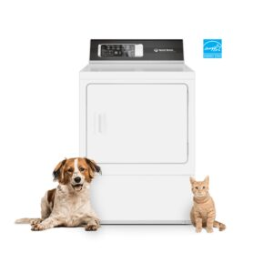
DR7004WE- $1305.38
7 c.f. sanitizing electric dryer with pet plus, steam, over dry protection, energy star certified, 10 preset cycles: anti-static, favorite cycle, speed cycle, Pet Plus cycle, steam refresh, steam boost, extended tumble, moisture senser, adaptive cool down technology .4 temperature selections. Cylinder light, reversible door, up front lint filter. 7-year parts and labor warranty.

