**Please call Roxanne to see if it is still available.**

**218-743-3132**

**DVE55CG7100W Regular $777.86 SALE $700.07**

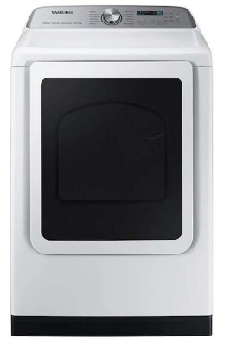Samsung, white 27” 7.4 c.f. smart electric dryer with steam sanitizer+ 12 preset drying options: refresh, steam sanitize+ normal, heavy duty, permanent press, bedding, delicates, activewear, time dry, air fluff, quick dry, downloaded. Nine drying cycles: wrinkle away, Eco normal, Towels, wool, sanitize, shirts, denim, low temp., rack dry. Ten options: damp alert, wrinkle prevent, adjust time (up), adjust time (down), child lock, sound on/off, smart care, drum light, smart control, and lint filter indicator.

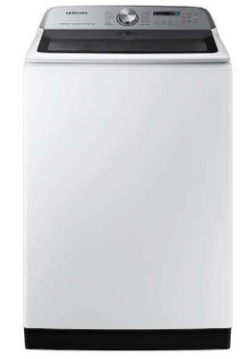

**WA54CG7105AW Regular $778.76 SALE $700.88**

Samsung, white 5.4 c.f. smart top load washer with ActiveWave agitator and SpeedWash. Twelve preset washing cycles: normal, bedding, waterproof, heavy duty, colors, whites, Activewear, delicates, quick wash, self-clean, rinse + spin, deep wash, downloaded. Five downloaded cycles: permanent press, wool, eco cold, denim, power rinse. Ten additional washing options: delay end, presoak, sound off, child lock, fabric softener, deep fill, super speed, smart care, smart control, spin speed. Five temperature settings: hot, warmer, warm, cool, cold. Five spin speeds: High, medium high, low, no spin. Active waterjet, child lock.